Freshman Year Time Capsule
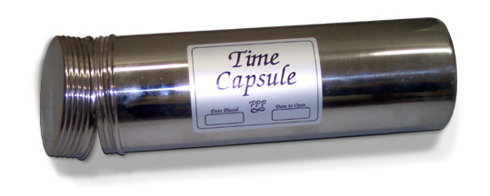
Dear Future __________________________________________________________

On the first day of my freshman year:

My favorite song is _______________________________________________________

My favorite movie is _____________________________________________________

My favorite book is _______________________________________________________

My best friend(s) is/are ________________________________________________

My favorite school subject is ____________________________________________

My favorite hobby is _____________________________________________________

My favorite sports team is ______________________________________________

What are you looking forward to the most about high school?
____________________________________________________________________________________________________________________________________________________________

My plan for the future (after high school) is to __________________________________
____________________________________________________________________________________________________________________________________________________________

Complete this sentence… If I was stuck on a deserted island and could bring three items with me I would bring _____________________________________________ ______________________________________________________________________________

One goal I have for my freshman year is to____________________________________ _____________________________________________________________________________

The person I admire the most is_________________________________________ and I admire this person the most because ________________________________________
________________________________________________________________________________________________________________________________________________________________________________________________________________________________________________________________________________________________________________________

